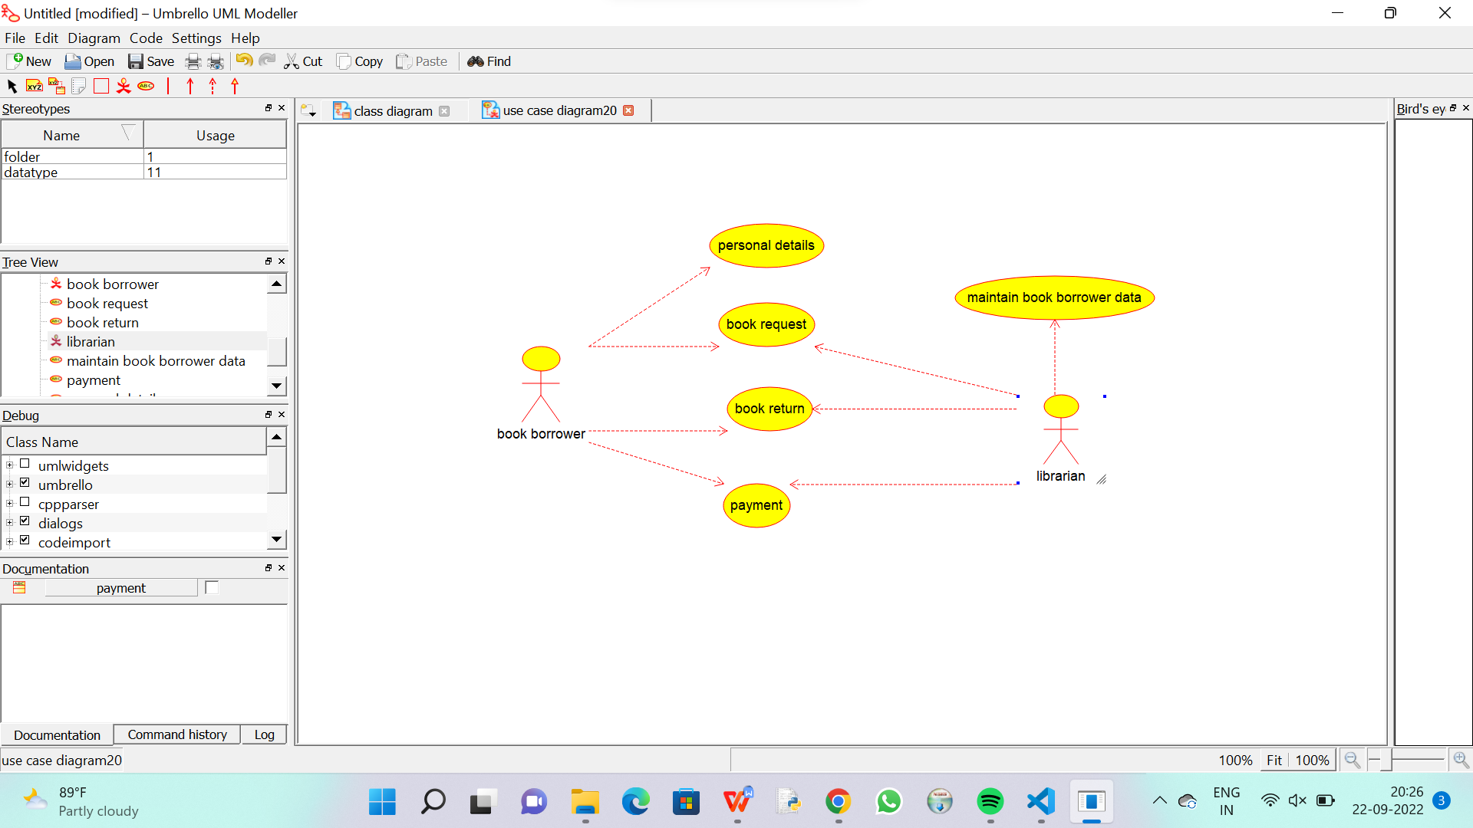

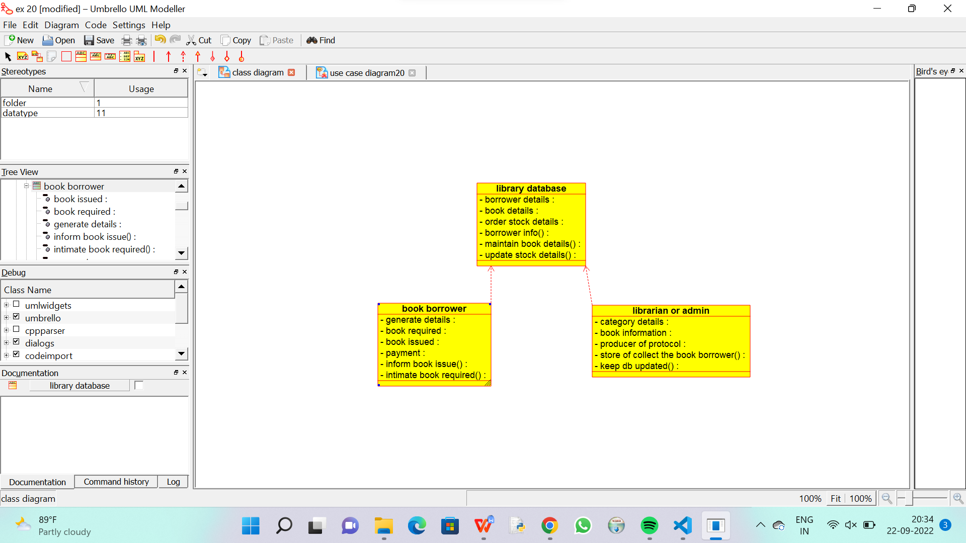

CODE FOR LIBRAIAN:

/**

 * Class librarian_or_admin

 */

public class librarian_or_admin {

  //

  // Fields

  //

  private void category_details;

  private void book_information;

  private void producer_of_protocol;

  private void store_of_collect_the_book_borrower_;

  private void keep_db_updated_;

  //

  // Constructors

  //

  public librarian_or_admin () { };

  //

  // Methods

  //

  //

  // Accessor methods

  //

  /**

   * Set the value of category_details

   * @param newVar the new value of category_details

   */

  private void setCategory_details (void newVar) {

    category_details = newVar;

  }

  /**

   * Get the value of category_details

   * @return the value of category_details

   */

  private void getCategory_details () {

    return category_details;

  }

  /**

   * Set the value of book_information

   * @param newVar the new value of book_information

   */

  private void setBook_information (void newVar) {

    book_information = newVar;

  }

  /**

   * Get the value of book_information

   * @return the value of book_information

   */

  private void getBook_information () {

    return book_information;

  }

  /**

   * Set the value of producer_of_protocol

   * @param newVar the new value of producer_of_protocol

   */

  private void setProducer_of_protocol (void newVar) {

    producer_of_protocol = newVar;

  }

  /**

   * Get the value of producer_of_protocol

   * @return the value of producer_of_protocol

   */

  private void getProducer_of_protocol () {

    return producer_of_protocol;

  }

  /**

   * Set the value of store_of_collect_the_book_borrower_

   * @param newVar the new value of store_of_collect_the_book_borrower_

   */

  private void setStore_of_collect_the_book_borrower_ (void newVar) {

    store_of_collect_the_book_borrower_ = newVar;

  }

  /**

   * Get the value of store_of_collect_the_book_borrower_

   * @return the value of store_of_collect_the_book_borrower_

   */

  private void getStore_of_collect_the_book_borrower_ () {

    return store_of_collect_the_book_borrower_;

  }

  /**

   * Set the value of keep_db_updated_

   * @param newVar the new value of keep_db_updated_

   */

  private void setKeep_db_updated_ (void newVar) {

    keep_db_updated_ = newVar;

  }

  /**

   * Get the value of keep_db_updated_

   * @return the value of keep_db_updated_

   */

  private void getKeep_db_updated_ () {

    return keep_db_updated_;

  }

  //

  // Other methods

  //

}

CODE FOR LIBRARY DATABASE:

/**

 * Class library_database

 */

public class library_database {

  //

  // Fields

  //

  private void borrower_details;

  private void book_details;

  private void order_stock_details;

  private void borrower_info_;

  private void maintain_book_details_;

  private void update_stock_details_;

  //

  // Constructors

  //

  public library_database () { };

  //

  // Methods

  //

  //

  // Accessor methods

  //

  /**

   * Set the value of borrower_details

   * @param newVar the new value of borrower_details

   */

  private void setBorrower_details (void newVar) {

    borrower_details = newVar;

  }

  /**

   * Get the value of borrower_details

   * @return the value of borrower_details

   */

  private void getBorrower_details () {

    return borrower_details;

  }

  /**

   * Set the value of book_details

   * @param newVar the new value of book_details

   */

  private void setBook_details (void newVar) {

    book_details = newVar;

  }

  /**

   * Get the value of book_details

   * @return the value of book_details

   */

  private void getBook_details () {

    return book_details;

  }

  /**

   * Set the value of order_stock_details

   * @param newVar the new value of order_stock_details

   */

  private void setOrder_stock_details (void newVar) {

    order_stock_details = newVar;

  }

  /**

   * Get the value of order_stock_details

   * @return the value of order_stock_details

   */

  private void getOrder_stock_details () {

    return order_stock_details;

  }

  /**

   * Set the value of borrower_info_

   * @param newVar the new value of borrower_info_

   */

  private void setBorrower_info_ (void newVar) {

    borrower_info_ = newVar;

  }

  /**

   * Get the value of borrower_info_

   * @return the value of borrower_info_

   */

  private void getBorrower_info_ () {

    return borrower_info_;

  }

  /**

   * Set the value of maintain_book_details_

   * @param newVar the new value of maintain_book_details_

   */

  private void setMaintain_book_details_ (void newVar) {

    maintain_book_details_ = newVar;

  }

  /**

   * Get the value of maintain_book_details_

   * @return the value of maintain_book_details_

   */

  private void getMaintain_book_details_ () {

    return maintain_book_details_;

  }

  /**

   * Set the value of update_stock_details_

   * @param newVar the new value of update_stock_details_

   */

  private void setUpdate_stock_details_ (void newVar) {

    update_stock_details_ = newVar;

  }

  /**

   * Get the value of update_stock_details_

   * @return the value of update_stock_details_

   */

  private void getUpdate_stock_details_ () {

    return update_stock_details_;

  }

  //

  // Other methods

  //

}

CODE FOR BOOK BORROWER :

/**

 * Class book_borrower

 */

public class book_borrower {

  //

  // Fields

  //

  private void generate_details;

  private void book_required;

  private void book_issued;

  private void payment;

  private void inform_book_issue_;

  private void intimate_book_required_;

  //

  // Constructors

  //

  public book_borrower () { };

  //

  // Methods

  //

  //

  // Accessor methods

  //

  /**

   * Set the value of generate_details

   * @param newVar the new value of generate_details

   */

  private void setGenerate_details (void newVar) {

    generate_details = newVar;

  }

  /**

   * Get the value of generate_details

   * @return the value of generate_details

   */

  private void getGenerate_details () {

    return generate_details;

  }

  /**

   * Set the value of book_required

   * @param newVar the new value of book_required

   */

  private void setBook_required (void newVar) {

    book_required = newVar;

  }

  /**

   * Get the value of book_required

   * @return the value of book_required

   */

  private void getBook_required () {

    return book_required;

  }

  /**

   * Set the value of book_issued

   * @param newVar the new value of book_issued

   */

  private void setBook_issued (void newVar) {

    book_issued = newVar;

  }

  /**

   * Get the value of book_issued

   * @return the value of book_issued

   */

  private void getBook_issued () {

    return book_issued;

  }

  /**

   * Set the value of payment

   * @param newVar the new value of payment

   */

  private void setPayment (void newVar) {

    payment = newVar;

  }

  /**

   * Get the value of payment

   * @return the value of payment

   */

  private void getPayment () {

    return payment;

  }

  /**

   * Set the value of inform_book_issue_

   * @param newVar the new value of inform_book_issue_

   */

  private void setInform_book_issue_ (void newVar) {

    inform_book_issue_ = newVar;

  }

  /**

   * Get the value of inform_book_issue_

   * @return the value of inform_book_issue_

   */

  private void getInform_book_issue_ () {

    return inform_book_issue_;

  }

  /**

   * Set the value of intimate_book_required_

   * @param newVar the new value of intimate_book_required_

   */

  private void setIntimate_book_required_ (void newVar) {

    intimate_book_required_ = newVar;

  }

  /**

   * Get the value of intimate_book_required_

   * @return the value of intimate_book_required_

   */

  private void getIntimate_book_required_ () {

    return intimate_book_required_;

  }

  //

  // Other methods

  //

}